**INSTITUTE OF ENGINEERING**

ADVANCED COLLEGE OF ENGINEERING AND MANAGEMENT

Kupondole, Lalitpur

**(AFFILIATED TO TRIBHUVAN UNIVERSITY)**



Lab no:5

Subject: Computer Network

**Submitted By: Submitted To:**

Department of Computer

and

Electronics Engineering

Name: Sameep Dhakal

Roll no: ACE074BCT063

Date: 09/07/2021

# Lab 5

# Title: Access Control List (ACL)

# Objective:

To Learn about filtering of the network traffic

# Introduction:

Access-list (ACL) is a set of rules defined for controlling the network traffic and reducing network attack. ACLs are used to filter traffic based on the set of rules defined for the incoming or outgoing of the network.

There are two main different types of ACL:

1. Standard Access-list:

These are the Access-list which are made using the source IP address only. These ACLs permit or deny the entire protocol suite. They don’t distinguish between the IP traffic such as TCP, UDP, Https etc.

1. Extended Access-list:

These are the ACL which uses both source and destination IP address. In this type of ACL, we can also mention which IP traffic should be allowed or denied. These use range 100-199 and 2000-2699.

# Design:

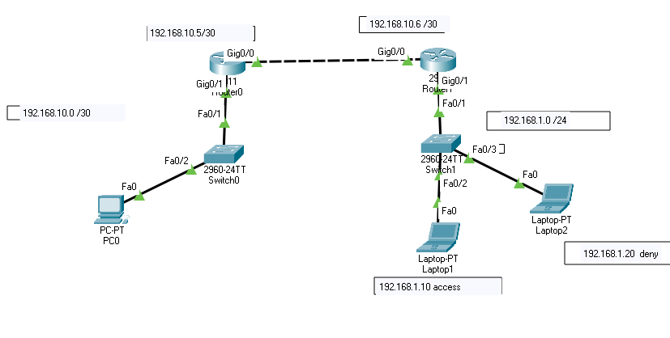

# Procedure:

1. First the required tools are selected.
2. The required ports of the routers were turned on.
3. Then th Ip and subnet mask of the laptops, pc and routers were set
   1. For each laptop and pc this was done by going to the desktop and Ip configurations
   2. For routers this was done by going to the configuration and selecting the required port
4. Required connections were made between the routers and laptops
5. Then the Acl is used in router for giving permission to the network traffics

# Code

Router0>enable

Router0# config terminal

Router0(config)#enable secret cisco

Router0(config)#line console 0

Router0(config-line)#password cisco

Router0(config-line) # login

Router0(config-line) # exit

Router0(config)#interface gig 0/0

Router0(config-if) # ip address 192.168.10.5 255.255.255.252

Router0(config-if) # no shutdown

Router0(config-if)#exit

Router0(config)#interface gig 0/1

Router0(config-if)#ip address 192.168.10.1 255.255.255.0

Router0(config-if)#no shutdown

Router0(config-if)#exit

Router0(config)#ip route 192.168.1.0 255.255.255.0 192.168.10.6

Access Control List

Specify the allow and deny address of the router port 0/1

Router0(config)#interface gig 0/1

Router0(config-if)#access-list 1 deny 192.168.1.20

Router0(config)#access-list 1 permit any

Router0(config)#interface gig 0/1

Router0(config-if)#ip access-group 1 in

Router0(config-if)#exit

Router1>enable

Router1# config terminal

Router1(config)#enable secret cisco

Router1(config)#line console 0

Router1(config-line)#password cisco

Router1(config-line) # login

Router1(config-line) # exit

Router1(config)#interface gig 0/0

Router1(config-if) # ip address 192.168.10.6 255.255.255.252

Router1(config-if) # no shutdown

Router1(config-if)#exit

Router1(config)#interface gig 0/1

Router1(config-if)#ip address 192.168.1.1 255.255.255.0

Router1(config-if)#no shutdown

Router1(config-if)#exit

Router1(config)#ip route 192.168.10.0 255.255.255.252 192.168.10.5

# Outputs:

Ping PC0 to Laptop1

Access Route

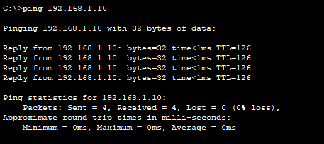

Ping PC0 to laptop2

Deny Route

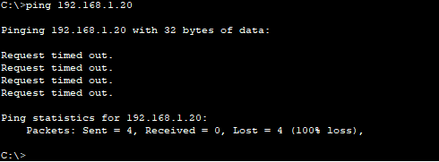

# Result and Conclusion

In this lab we able to filter traffic from the network and which can be used for blocking the access of unwanted routes.